**CCT College Dublin**

**Assessment Cover Page**

|  |  |
| --- | --- |
| **Module Title:** | Databases - Approaches & Systems |
| **Assessment Title:** | CA 1 Integrated Databases and OCC (20%) |
| **Lecturer Name:** | **Taufique Ahmed** |
| **Student Full Name:** | Luis Ramirez, Telmuun dunia, Alejo Santos |
| **Student Number:** | 2023169, 2023306, 2023197. |
| **Assessment Due Date:** | Sunday, 15 December 2024, 11:59 PM |
| **Date of Submission:** |  |

**Declaration**

|  |
| --- |
| By submitting this assessment, I confirm that I have read the CCT policy on Academic Misconduct and understand the implications of submitting work that is not my own or does not appropriately reference material taken from a third party or other source. I declare it to be my own work and that all material from third parties has been appropriately referenced. I further confirm that this work has not previously been submitted for assessment by myself or someone else in CCT College Dublin or any other higher education institution. |

Contents

**Database Documentation.** 1

Updated Components from checkpoint 1: 1

Physical design: Produce the SQL and create statements for each relation, including INSERT statements (dummy data). 5

**OOC Documentation.** 8

# **Database Documentation.**

## Updated Components from checkpoint 1:

For this part what we did was create a new schema since there are 3 of us working on this project, so we decided to create a new one and work on it.

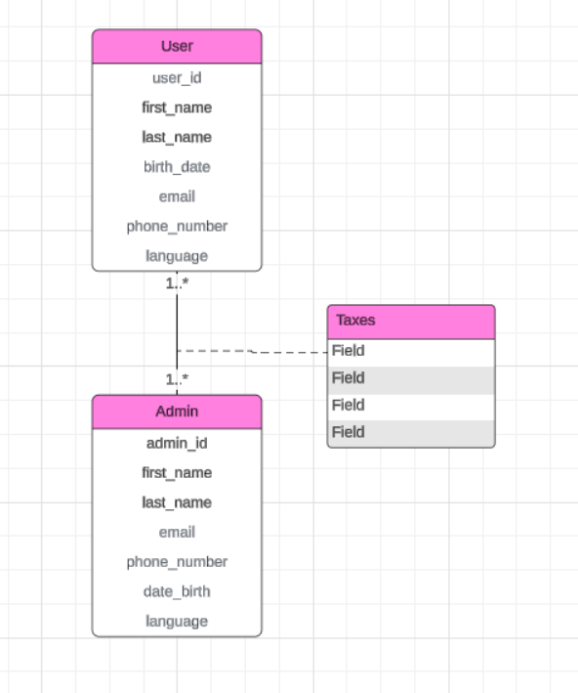

We started creating this from scratch.

After that, the next step was normalization. Starting from the 1NF, eliminating repeating groups in individual tables, creating the tables for each data, and lastly identifying the PK.

After applying the 1NF: The tables looked like this:

Eliminates repeating groups in individual tables.

We eliminated the redundant attributes, both user and admin tables had identical fields like first_name, last_name, etc. This causes duplication. So, what we did instead we create a person table.

Each row is unique, and a primary key is introduced, such as a user_id, person_id, admin_id, and tax_id.

The taxes table had no relationship with other tables, no attributes, and no PK. We fixed that with the 1NF.

2NF:

The established relationship between every table:

**User table with person table.**

One-to-One (1:1): Each User has exactly one corresponding Person, and vice versa. This is enforced by the user_id foreign key in the Person table.

**Person table with admin table.**

One-to-Many (1:N): A Person can be associated with many Admin records, but an Admin can only be associated with one Person. This is enforced by the admin_id foreign key in the Person table.

**Admin table with taxes tables.**

Many-to-Many (M:N): An Admin can be assigned to many Taxes, and a Tax can be assigned to many Admins. This relationship is implemented using the TaxAssignment junction table.

**Taxes table with taxAssignment table.**

One-to-Many (1:N): A Tax can be assigned to many TaxAssignments, but a TaxAssignment can only be associated with one Tax. This is enforced by the tax_id foreign key in the TaxAssignment table.

**User table with taxes**

Many-to-Many (M:N): A User can be assigned to many Taxes, and a Tax can be assigned to many Users. This relationship is implemented using the TaxAssignment junction table.

**Tax table with TaxPayment table.**

One-to-Many (1:N): A Tax can have many TaxPayments, but a TaxPayment can only be associated with one Tax. This is enforced by the tax_id foreign key in the TaxPayment table.

2NF, for this task, we made sure that no partial dependency exists. We have already addressed many normalization issues in 1N. In 2NF, we further refine by ensuring that every non-key attribute depends on the entire primary key. Also, there are no redundant fields on any table.

So, the conclusion is every table has a single-column primary key. All non-key attributes depend on the entire primary key. But we decided to split the taxes tables in 3 since we had a few characteristics with potential dependencies in the taxes table that if you combine them with other data, could generate a duplicate. So, instead, we created 2 tables from taxes, one is “tax payments” and we created attributes as payment_id as a PK tax_id as FK and paid_by as FK. And, the second table was called tax_assignment with a composite key consisting of the tax_id in the taxestable and assigned_by referencing the user_id in the usertable.

3NF:

In the 3rd formal notation, we had to analyze if there was any violation of 3NF.

We found that in the taxpayment table, the paid_by attribute is dependent on the assigned_by attribute, which is not a primary key. This a dependency, and this one was violating the 3NF rule.

Without separating the attribute assigned_by attribute to another table the same user information could be repeated in many taxpayments records, and this could lead to a data redundancy. So, we figured this out by introducing a new table called “assigned user” by creating this table we eliminated the dependency and we reduced data redundancy. Which lead a more normalized and efficient database design.

Therefore, after all these updates the schema looked like this.

## Physical design: Produce the SQL and create statements for each relation, including INSERT statements (dummy data).

For this task we put all the data inside the MySQL Workbench, creating the tables and attributes and also putting dummy information as an example.

Dummy data on person table.

Dummy data on tax payment table.

Admin table.

User table.

# **OOC Documentation.**

Figure 1 - Above is a flow chart indicating the program architecture

The user login classes and database setup classes all inherit and extend the DB_Connection class to utilize the information stored in the father class. We aimed to store as little logic in the main class as possible, and only call methods and properties from the other classes and implement the menu structure in the main class.

Figure 2 - User and Admin has been created as a seperate class with their own son Login classes to handle prompting the DB to match the data.

To create a connection between the database and the Java file, we had to inherit attributes from the DB_Connection file as a parent, using the extends keyword.

This java inheritance is because the DB_Connection file contains all relevant information about the database like the user, password, table names and the database URL (name and port to connect). When a class try to modify, upload or delete information stored in the database, it has to first create the connection with the right credentials, and then continue with the process.

One example is the DatabaseReader file, which is responsible for making sure that the database exists in MySQL application, and doesn’t crash using a while loop.

Figure 3 - User login Action method to query the MySQL DB and check if the information given matches the information in the database.

Figure 4 - Add user method is also added with INSERT TO syntax that will create and add users to the Database.

Figure 5 - All interactions with the MySQL DB is being made within code, with syntaxes such as CREATE, INSERT, SELECT AND DELETE

Figure 6 - Example of a method that will change the user data in a table, to be queried as a syntax

Figure 7 - Remove a user from the DB using syntax

Figure 8 - UserHistory arraylist to store changes made to the Database and list them out when required.

Figure 9 - Regex validation check for every possible input from the user.